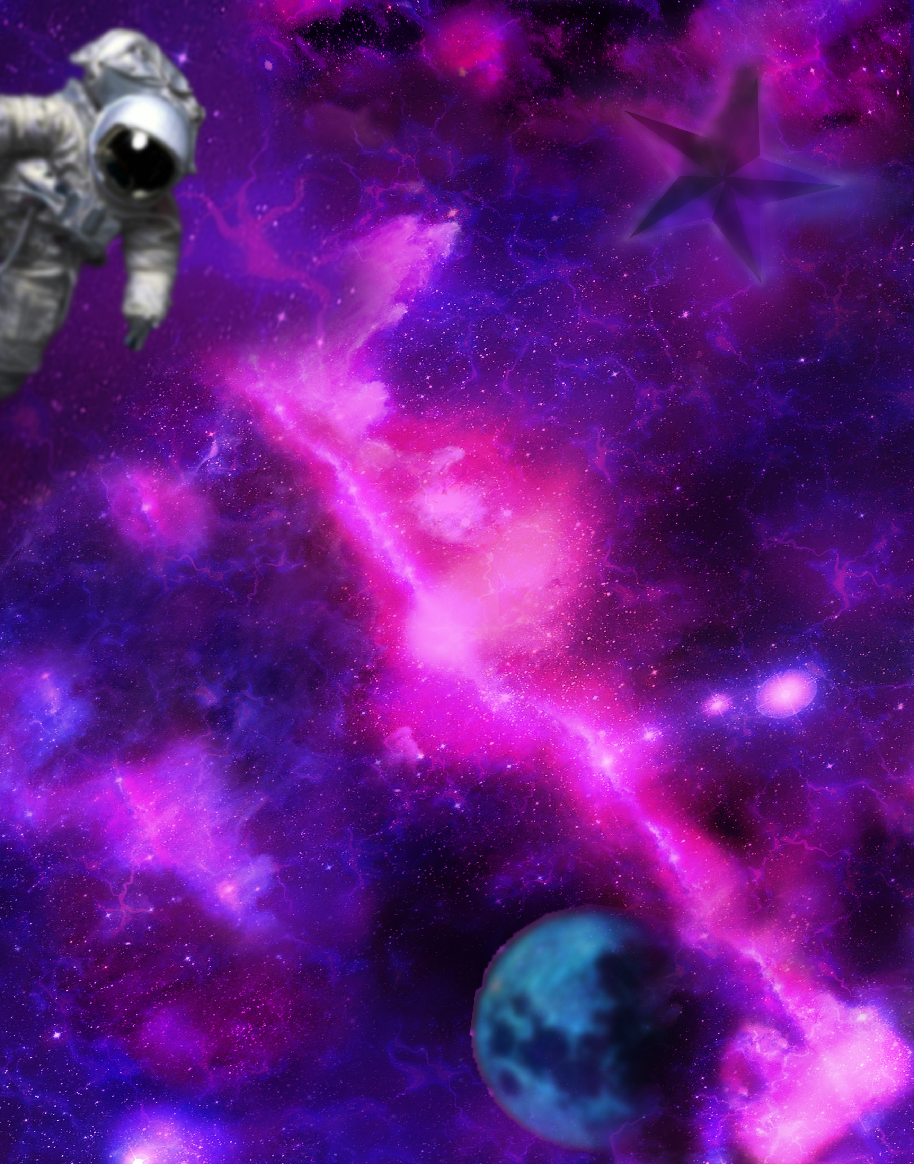

**THE ART**

**IN OUR WORLDS**

**NasArt**

Table of content

The Challenge

NASA is moving its data to the cloud, and Machine Learning/Artificial Intelligence (ML/AI) can offer an innovative means to analyze and use this massive archive of free and open data. Your challenge is to create an application using ML/AI techniques that allows users to input short text phrases, matches that input to NASA science data or imagery, and displays the results for the user in a creative and artistic manner.

Solution Summery

**High-level summary:**

The solution that we developed to Art in Our Worlds challenge is a web site that allows users to input short phrases (text or voice) and matches that input to NASA science data and imagery then displays the output in the following formats:

* Documents
* Images
* 3D images which can be accessed by virtual reality headsets
* Images manipulated in an artistic manner
* Funny filters with the output images
* ………….. // lesa na2s

And the user can share all this data with others.

**Technical approaches:**

We developed a website to allow the user to interact with NASA data using the following algorithms and Artificial intelligence models:

* Speech recognition model for the search by voice feature using deep speech library.
* Document-to-document similarity // lesa na2s
* Image to text // lesa na2s
* VR// lesa na2s
* ….// lesa na2s
* …..// lesa na2s

**Project outcomes:**

The project provided great, creative and interesting interface that helps both scientists, researchers and public users to assess NASA’s data.

**Project Importance:**

the project made all this useful data accessible to the general public and all the types of audience and the ability of sharing makes it easier to spret knowledge among the society.

**Detailed Project Description**

Provide additional details about your project.

259

What exactly does it do?

How does it work?

What benefits does it have?

What do you hope to achieve?

What tools, coding languages, hardware, or software did you use to develop your project

**Space Agency Data**

Provide specific details about what space agency data you used in your project, how you used it, or how it inspired your project. Remember: You are welcome to use any open data in your project. However, to be eligible for Global Judging, you must use at least some open-source data from NASA and/or from one of the Space Agency Partners for 2022 (Australian Space Agency, Brazilian Space Agency, Canadian Space Agency, European Space Agency, Indian Space Research Organisation, Japan Aerospace Exploration Agency, Mexican Space Agency, National Space Activities Commission of Argentina, National Space Science Agency of Bahrain

**Hackathon journey**

**References**

Speech to text:

Deep speech Deep speech is made up of two pre-trained models that we have to download. It is made up of the Acoustic model and the Language model.